

**ORCHID FLOWER TRADING & AUCTION PLATFORM**

**REPORT**

**Software Design Document**

**Nguyễn Phan Phước Thịnh – SE160111**

**Trịnh Phan Chí Hiếu - SE161308**

**Nguyễn việt hoàng - SE150782**

**Nguyễn Quốc Thái - SE150466**

**Huỳnh Minh Toàn - SE161590**

– HCM, March 2024 –

**Table of Contents**

I. Record of Changes 3

I. Software Requirement 4

1.Actors 4

2. Use Case diagram 4

3. Non-Functional Requirements 4

3.1 External Interfaces 4

3.2 Quality Attributes 5

4. Business Rules 5

II. Software Design Document 6

1. System Design 6

1.1 System Architecture 6

1.2 Package Diagram 6

2. Database Design 7

3. Detailed Design 8

3.1 <Feature/Function Name1> 8

3.2 <Feature/Function Name2> 9

4. Deployment Design 10

# Record of Changes

|  |  |  |  |
| --- | --- | --- | --- |
| **Date** | **A* M, D** | **In charge** | **Change Description** |
| 19/01/2024 | **A\*** | Thịnh | Added document. Added actors |
| 24/01/2024 | **A\*** | Hiếu | Added Use Case |
| 26/01/2024 | **A\*** | Thịnh | Added Database Model |
| 28/01/2024 | **A\*** | Hoàng + Thái | Added Non-Function Requirment |
| 29/01/2024 | **A\*** | Hiếu | Added Introduction |
| 29/01/2024 | **A\*** | Toàn | Added Business Rule |
| 14/03/2024 | **A\*** | Thịnh | Finished Database details, added system architecture |
| 15/03/2024 | **A\*** | Hiếu | Added sign-up, login sequence diagram |
| 15/03/2024 | **A*, M** | Thịnh, Hiếu | Added register auction, register bids, comment sequence diagram.  Added manage users diagrams, edited sign-up, login sequence diagram. |
|  |  |  |  |
|  |  |  |  |
|  |  |  |  |
|  |  |  |  |
|  |  |  |  |

*A - Added M - Modified D - Deleted

# I. Introduction

**Members**:

|  |  |
| --- | --- |
| Nguyễn Phan Phước Thịnh | SE160111 |
| Trịnh Phan Chí Hiếu | SE161308 |
| Huỳnh Minh Toàn | SE161590 |
| Nguyễn Việt Hoàng | SE150782 |
| Nguyễn Quốc Thái | SE150466 |

**The Orchid Flower Trading and Auction Platform is designed to modernize the traditional orchid market. This application leverages technology to provide an interactive, user-friendly trading platform, simplifying and enhancing the efficiency of orchid transactions. Its main functions include: improving market accessibility for orchids, optimizing the auction process, and offering a comprehensive management system for both buyers and sellers.**

**This is a primarily WebAPI application.**

# II. Software Requirement

## 1.Actors

|  |  |  |
| --- | --- | --- |
| **#** | **Actor** | **Description** |
| 1 | Customer | - Search, view, and engage in trading Orchid flowers on the system.  - Participate in Orchid flower auctions organized by the system.  - Rate, provide feedback, and report on transactions.  - Track and manage orders. |
| 2 | Orchid Owner | - Create new products for sale.  - Register products for auction.  - Access financial statistics, revenue information, and order tracking. |
| 3 | Manager | - Assign auction management tasks to staff.  - Administer staff accounts.  - Manage orders and handle reports and customer comments. |
| 4 | Staff | - Confirm and manage orders.  - Review products for sale.  - Operate auctions, including configuring starting prices, price steps, and opening/closing times. |
| 5 | Administrator | - Manage payment transaction logs, including depositing and withdrawing money from the system's OPay wallet platform.  - Access statistics and revenue reports.  - Manage account managers.  - Additionally, ensure that all transactions go through the system's OPay wallet platform, and payment transaction logs must be accurately recorded. |

## 2. Use Case diagram

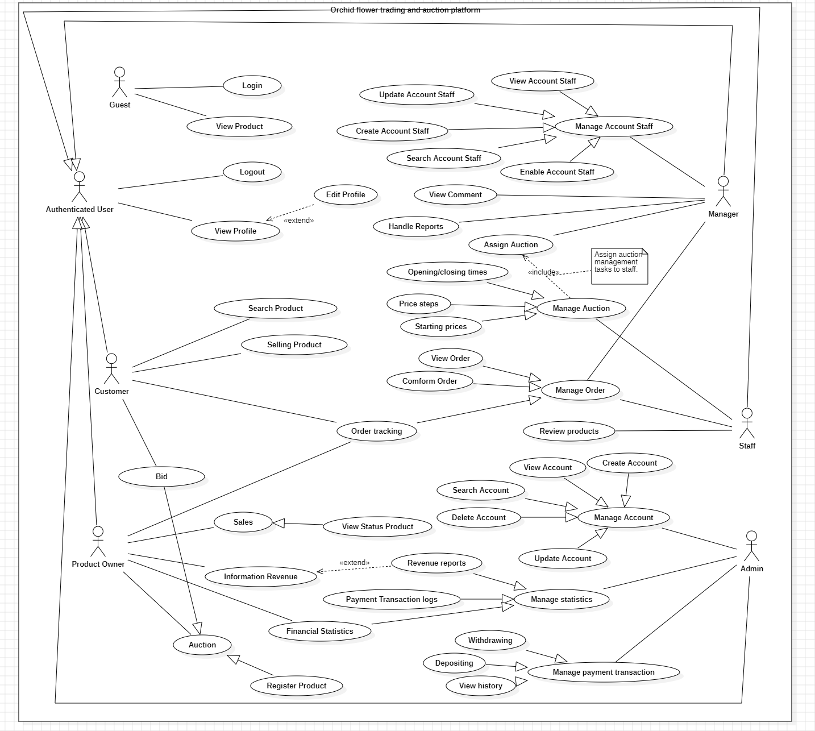

## 3. Non-Functional Requirements

### 3.1 External Interfaces

**3.1.1 Hardware Interface**

* The system shall be accessible from any device with an internet connection, including desktop computers, laptops, tablets, and smartphones.
* The system shall be compatible with major web browsers, including Google Chrome, Mozilla Firefox, Microsoft Edge, and Apple Safari.

**3.1.2 Software Interface**

* The system shall integrate with a secure payment gateway to process online transactions.
* The system shall integrate with third-party authentication providers, such as Google, for user authentication and login.

**3.1.3** **User Interface**

* The authenticated users UI must be fully shown in web application.
* The user interface shall be designed to be user-friendly and intuitive, with clear navigation and easy-to-use search and filtering functions.

**3.1.4** **Communication Interface**

* The system can call API through data transferred by HTTP.
* The system shall use encryption to ensure secure communication between the user's device and the server.
* The system shall use email notifications to communicate with users, such as order confirmation and password reset instructions.

### 3.2 Quality Attributes

#### 3.2.1 Usability

* All text, labels and notices must be uniformly written in English and be translatable into other secondary languages.
* The web application should be friendly and easy for users to using.
* The web application for admin should require no more than 2 days of training of use.

#### 3.2.2 Reliability

* Systerm is divided into 3 roles: Guest, Customer and Admin.
* All input data are validated before saving to the database.
* Each role only access to a group of functions.
* The system always checks authentication and authorization before making any features.
* The system shall use industry-standard encryption and secure protocols to protect user data and prevent unauthorized access.
* Data recovery range : Can recover data up to 24h ago
* Business continuity requirements : In disaster case, system can recover data
* Secure coding, web server setting: Implement measures against threats and vulnerabilities specific to web applications

#### 3.2.3 Performance

* The system shall load pages and search results quickly, with a response time of no more than 3 seconds.
* Operation time is 24/7
* Session timeout: 30 mins

## 4. Business Rules

|  |  |
| --- | --- |
| **ID** | **Rule Definition** |
| BR-01 | The customer can search, view, and participate in orchid transactions on the system that allow customers to perform basic operations such as searching for products, viewing product information, and placing orders. |
| BR-02 | The customer must select a payment method and provide the necessary information |
| BR-03 | Orchid owners can register auction products that allow orchid owners to list their products for auction on the system. |
| BR-04 | The manager can manage orders that allow managers to handle issues related to orders, such as confirming orders, processing customer complaints, and issuing refunds. |
| BR-05 | The manager must have the appropriate authority to approve purchase orders based on the order value |
| BR-06 | The manager must report auction results to upper management. |
| BR-07 | The highest bidder at the close of the auction wins the item. |
| BR-12 | Only registered bidders can participate in the auction. |
| BR-24 | The administrator can manage account managers. |
| BR-33 | The administrator must ensure that all payment transaction logs include depositing and withdrawing money from the system's OPay wallet platform. |

# 

# III. Software Design Document

## 1. System Design

### 1.1 System Architecture

* **Clean Architecture with MVVM** 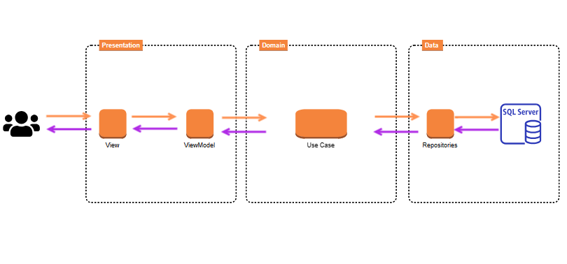
* **Database: SQL Server**
* **WebAPI: C#, .NET**

### 1.2 Package Diagram

*[Provide the package diagram for each sub-system. The content of this section includes overall package diagram(s) and the explanation for each package (or namespace). Please see the sample and description table format below]*

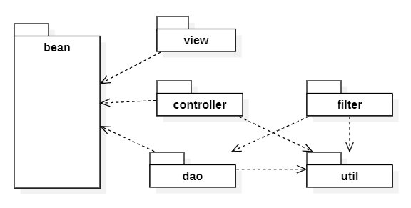

***Package Descriptions***

|  |  |  |
| --- | --- | --- |
| **No** | **Package** | **Description** |
| 01 | <Package name> | <Description of the package> |
| 02 |  |  |

## 2. Database Design

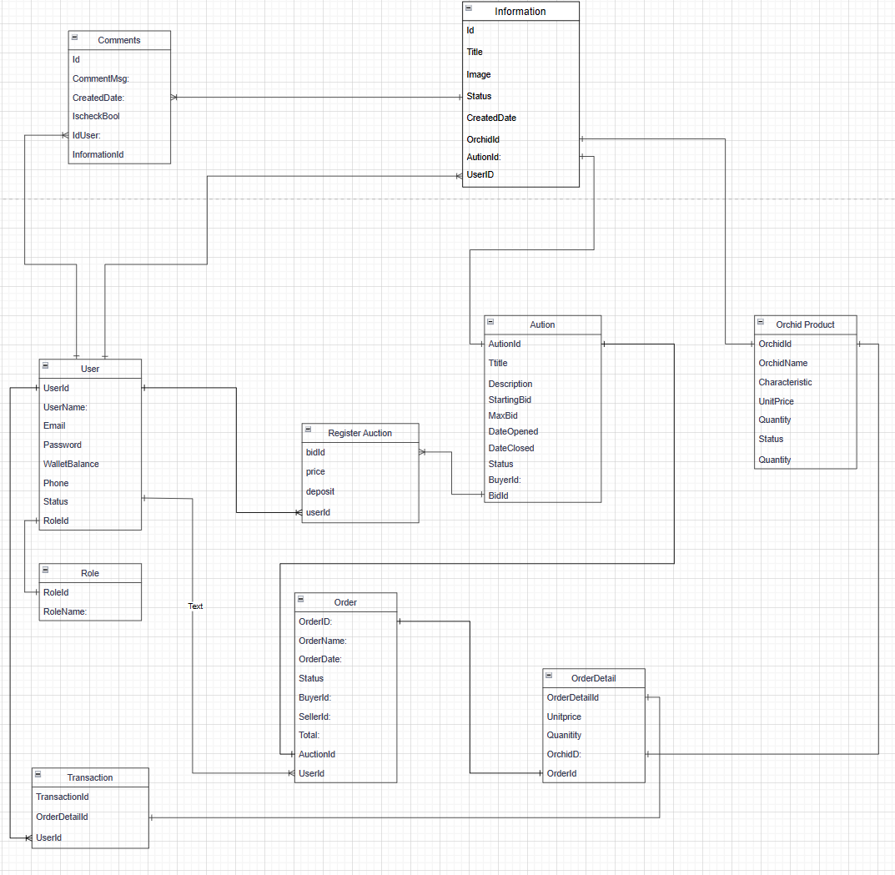

***Table Descriptions***

|  |  |  |
| --- | --- | --- |
| **No** | **Table** | **Description** |
| ***01*** | User | *Stores user login information, user’s profile*  *-* ***UserID****:*  *- UserName*  *- Email*  *- Phone*  *- WalletBalance*  *- Status*  *- Foreign keys:* ***RoleId*** |
| ***02*** | Role | *Stores user’s role*  *-* ***RoleId***  *- RoleName* |
| ***03*** | Register Auction | *Store customer’s biddings*  *-* ***BidID***  *- BidPrice*  *- Deposit*  *- Foreign keys:* ***UserId*** |
| ***04*** | Auction | *Stores auctions listed by product owner.*  *-* ***AuctionId***  *- Title*  *- Description*  *- StartingBid*  *- MaxBid*  *- DateOpened*  *- DateClosing*  *- Status*  *- Foreign keys:* ***UserId, BidId*** |
| ***05*** | Comments | *Stores comments made by customers on auctions*  *-* ***CommentId***  ***-*** *CommentMsg*  *- DateCreated*  *- Foreign keys:* ***UserId, InformationId*** |
| ***06*** | Information | *Store’s auction or orchid product information*  *-* ***InformationId***  *- Title*  *- Image*  *- Status*  *- DateCreated*  *- Foreign keys:* ***AuctionId, OrchidId, UserId*** |
| ***07*** | Orchid Product | *Stores orchid products.*  *-* ***OrchidId***  *- OrchidName*  *- Characteristic*  *- UnitPrice*  *- Quantity*  *- Status* |
| ***08*** | Transaction | *Stores all transactions made by customers.*  *-* ***TransactionId****:*  *- Foreign keys:* ***OrderDetailId, UserId*** |
| ***09*** | Order | *Stores customer’s order*  *-* ***OrderId***  *- OrderName*  *- OrderDate*  *- Status*  *- Total*  *- Foreign keys:* ***AuctionId, UserId*** |
| ***10*** | Order Detail | *Stores Cart Detail*  *- OrderDetailId*  *- UnitPrice*  *- Quantity*  *- Foreign keys:* ***OrchidId, OrderId*** |

## 3. Detailed Design

### 3.1 Login

***Sign in sequence diagram***

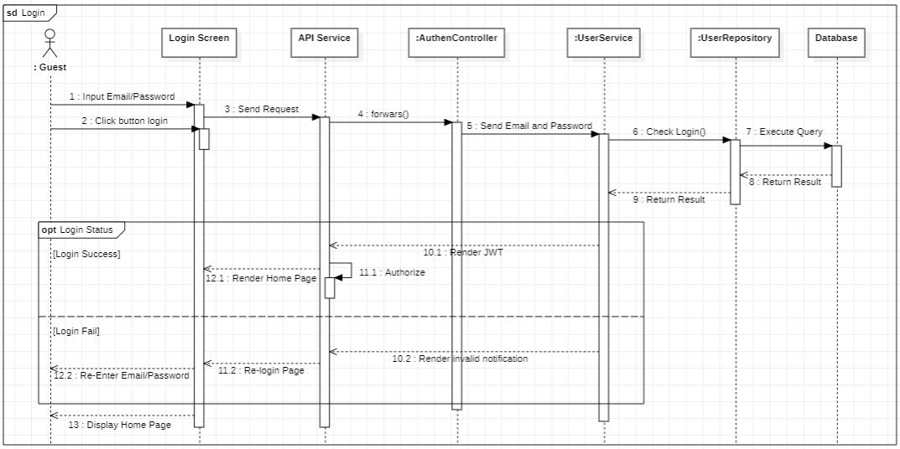

### 3.2 Sign up

***Sign up sequence diagram***

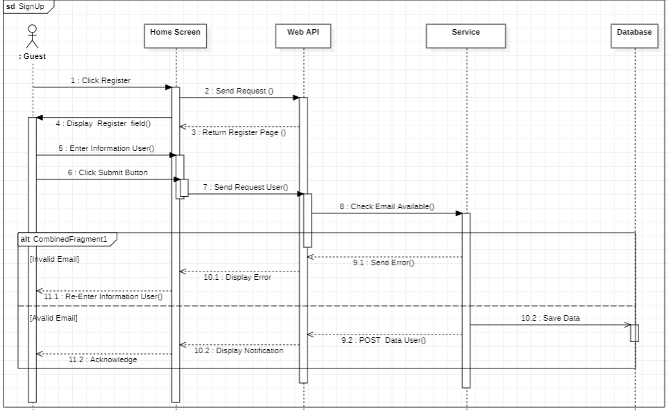

### 

### 3.3 Register Auction

***Register auction sequence diagram***

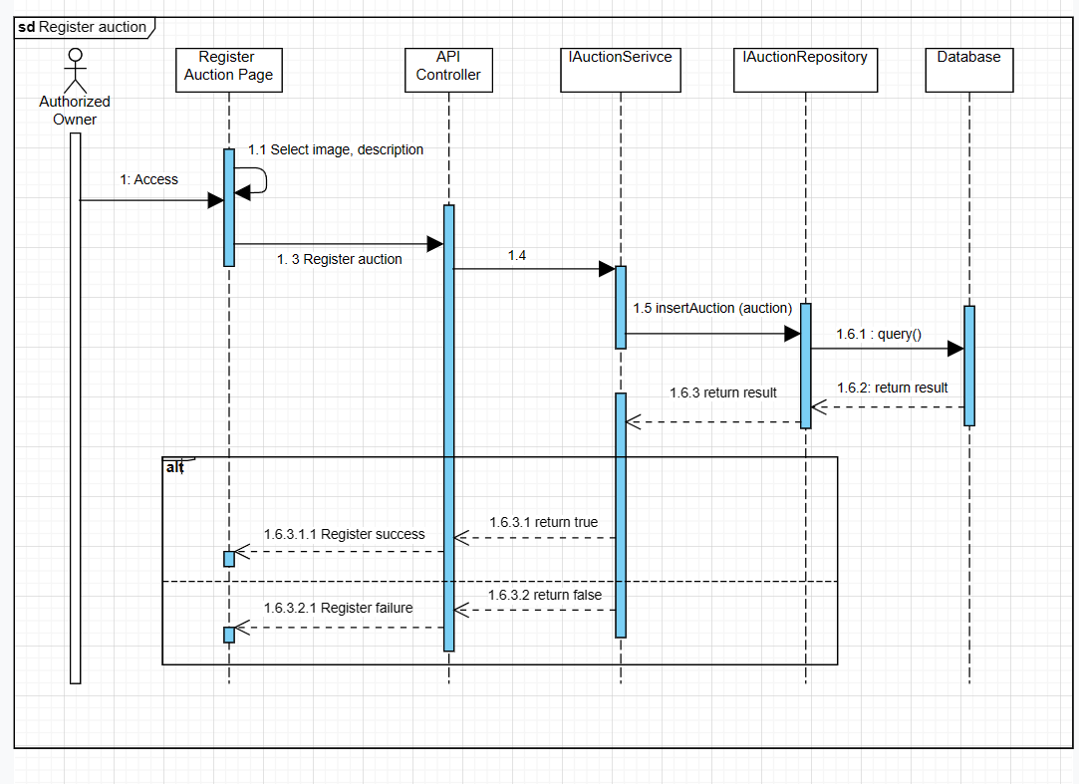

### 

### 3.4 Register Bids

***Register biddings sequence diagram***

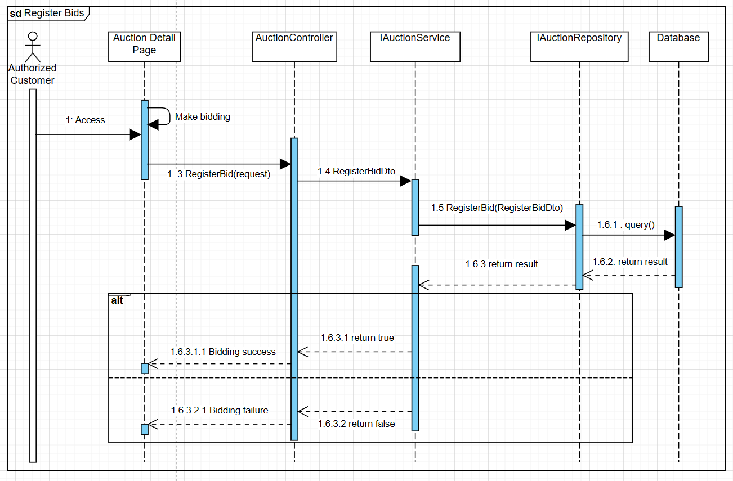

### 

### 3.5 Comment

***Comment sequence diagram***

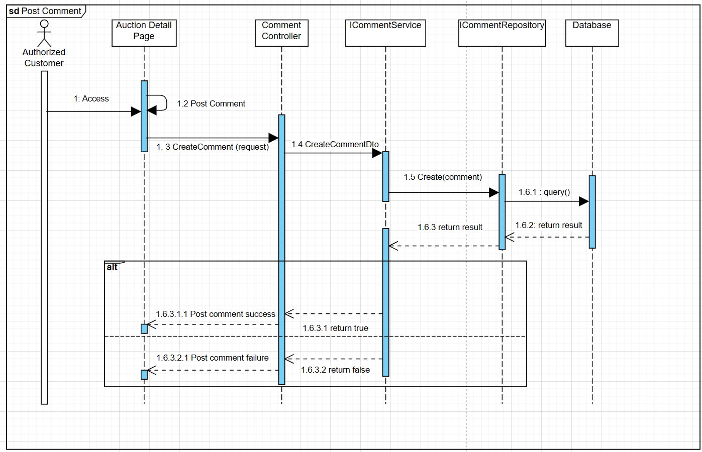

### 3.6 Manage User

***3.6.1 Get all users***

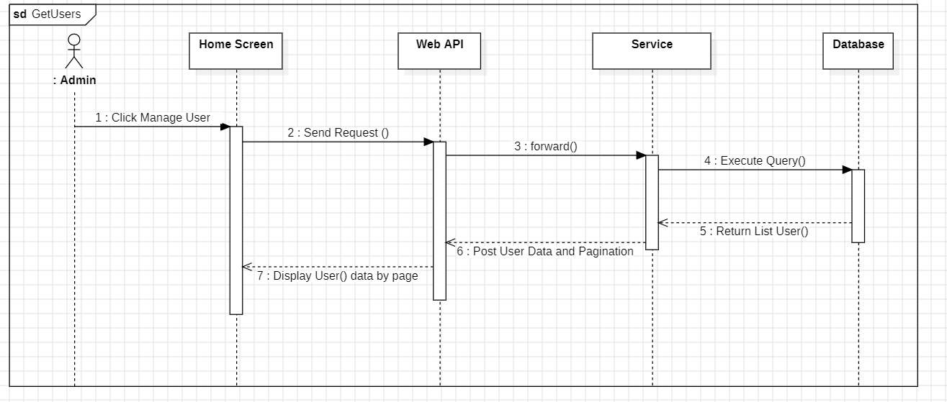

***3.6.2 Update user***

